**DAILY ONLINE ACTIVITIES SUMMARY**

|  |  |  |  |  |  |  |  |  |
| --- | --- | --- | --- | --- | --- | --- | --- | --- |
| **Date:** | **10/06/2020** | | | | | **Name:** | **V ANJANA PAI** | |
| **Sem & Sec** | **IV sem & B section** | | | | | **USN:** | **4AL18CS094** | |
| **Online Test Summary** | | | | | | | | |
| **Subject** | | **OBJECT ORIENTED CONCEPTS** | | | | | | |
| **Max. Marks** | | **30** | | **Score** | | | **--** | |
| **Certification Course Summary** | | | | | | | | |
| **Course** | **Java Programming** | | | | | | | |
| **Certificate Provider** | | | **Great learning academy** | | **Duration** | | | **3.5 hours** |
| **Coding Challenges** | | | | | | | | |
| **Problem Statement1:** Write a Java Program to find total number of subarrays which start and end with same element.  **Problem Statement2:** Write a Java Program to count all the triplets such that sum of two elements equals the third element.  **Problem Statement3:** Write a C Program to print the sum of boundary elements of a matrix.  **Problem Statement4:** Write a Java Program to find the longest repeating sequence in a string. | | | | | | | | |
| **Status: Executed** | | | | | | | | |
| **Uploaded the report in GitHub** | | | | | **YES** | | | |
| **If yes Repository name** | | | | | **lockdown-coding** | | | |
| **Uploaded the report in slack** | | | | | **YES** | | | |

**Online Test Summary:** Due to some network issues I could not take up the test properly. The test got auto-submitted within few minutes of start.

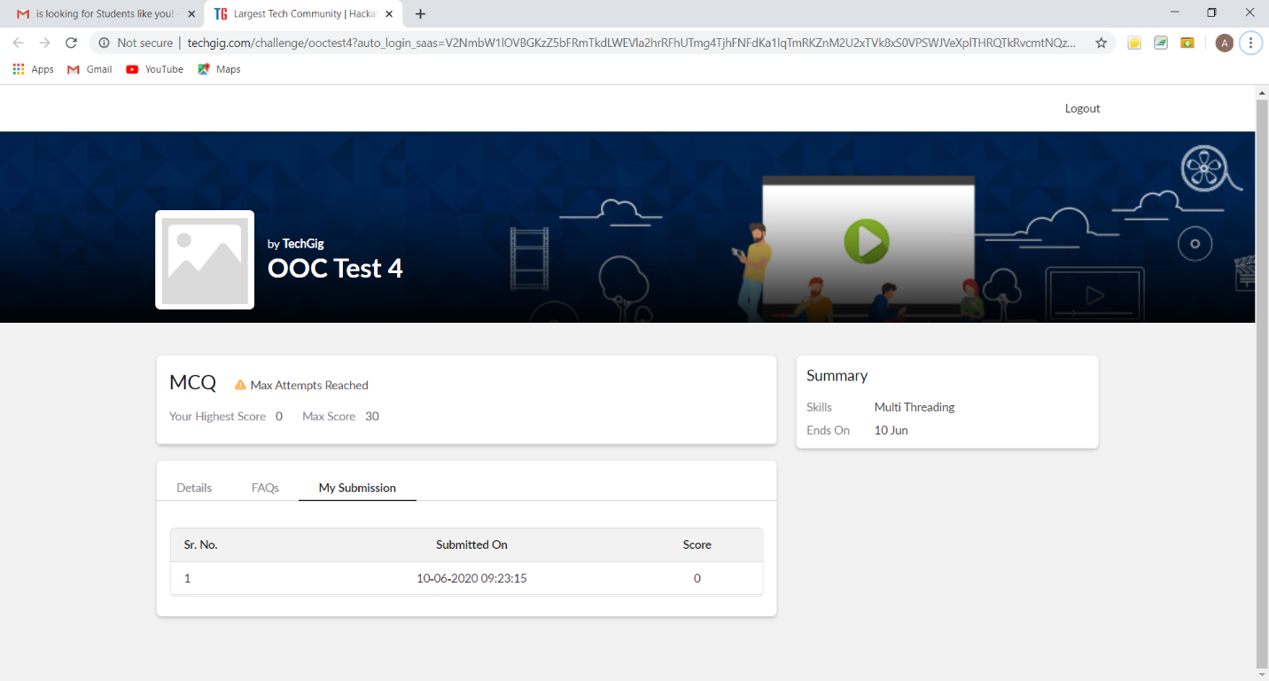

This is the snapshot of today’s test where it got auto submitted.

**Online Certification Course Summary:** In today’s session of java Programming I learnt about the Operations, Flow Control Statements and about Arrays in Java.

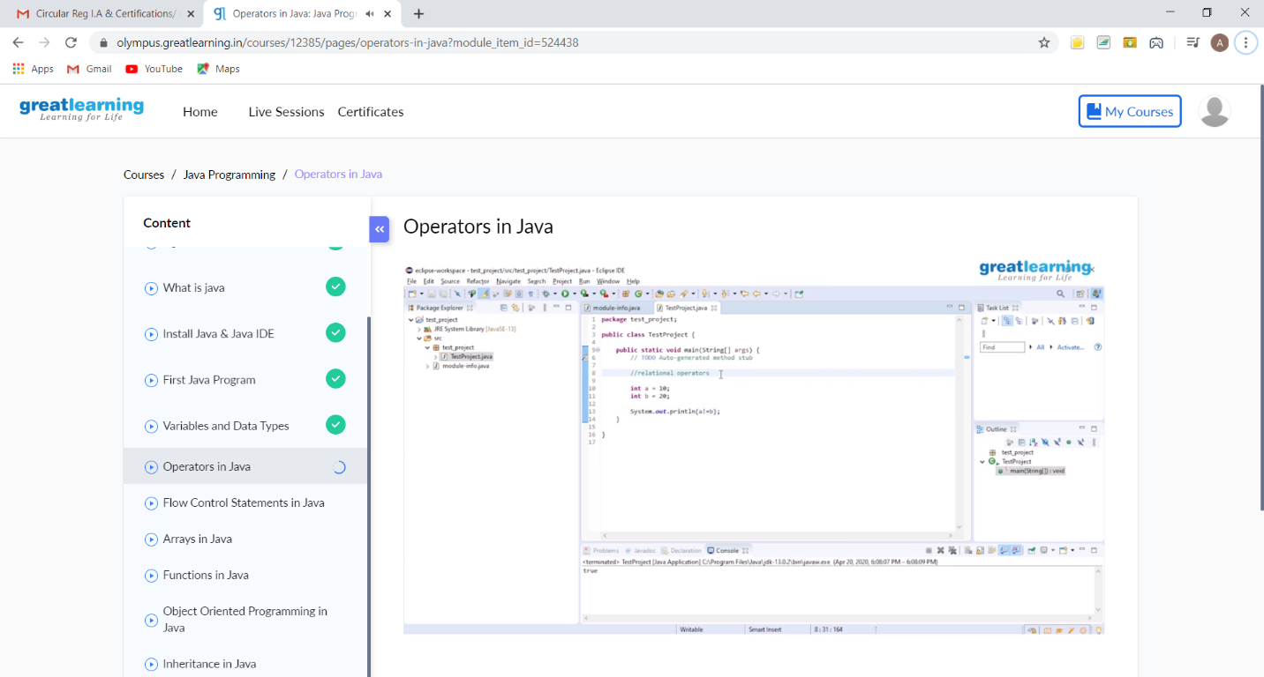

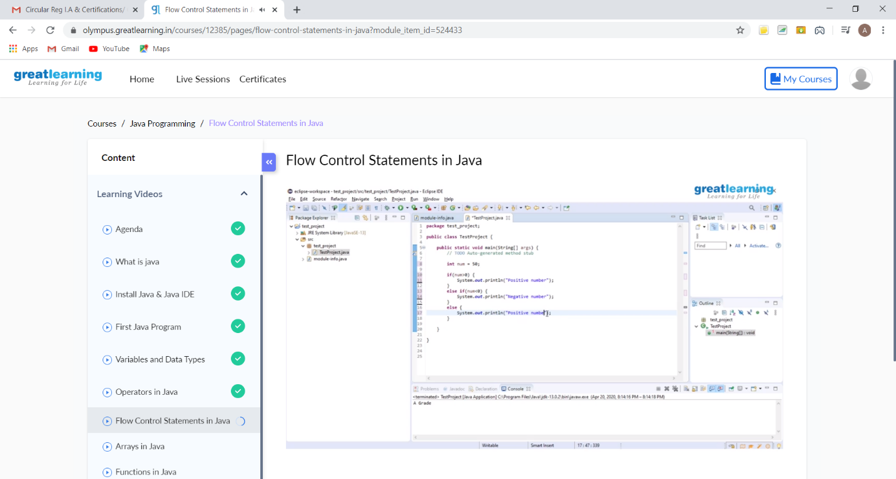

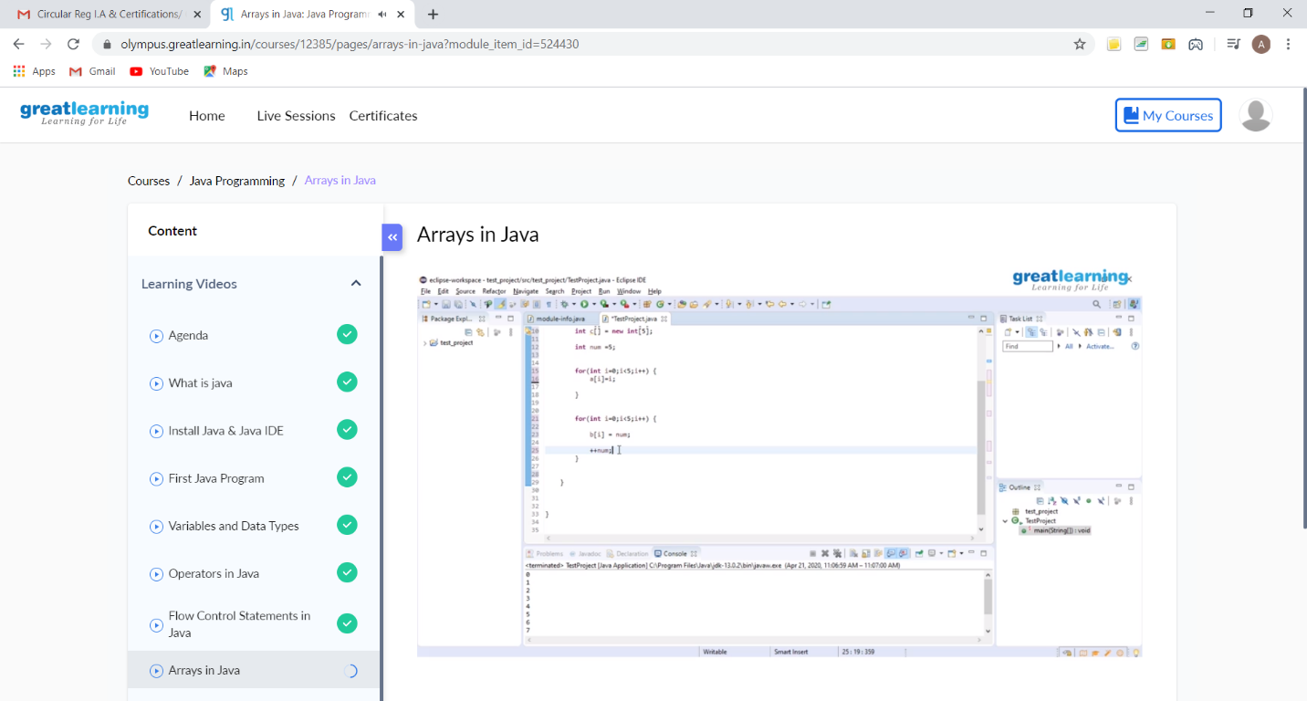

**These are the Snap shots of today’s sessions**.

**Online Coding Summary:** Today I had received one program from prof. Vasudev CSE Dept and another from prof. Reena Lobo CSE Dept. and also, I have received two programs from prof. Shilpa CSE Dept yesterday evening (i.e. problem statement 1 & 2). The programs are mentioned above in the coding challenges(pg.01). I have also uploaded it to my GitHub repository.

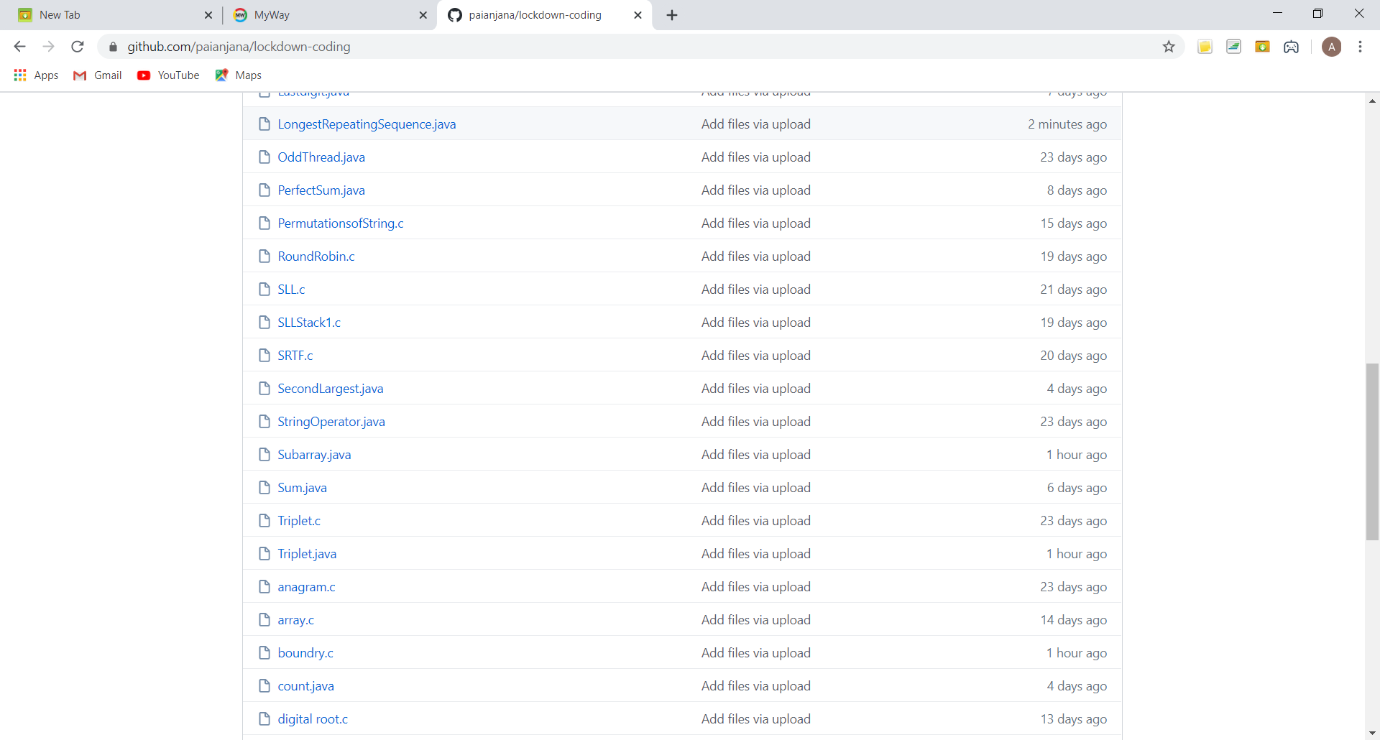

It is the snap shot of my repository where I have uploaded the code. File name is Subarray.java, Triplet.java, boundry.c and LongestRepeatingSequence.java